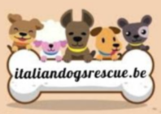

**Italiandogsrescue.be**

• Name and surname of the adopter

•

• Owner of the dog's microchip.

•

• Age of the adopter (no minors).

•

• Place of residence - City province address:

• Landline and mobile telephone:

• Email address:

• You are looking for a dog yes or no

• Gender: female - male

• Dog size: small - medium - large

• Coat: long or short

• Age:

•

• Would your message be to move to adopt him yes or no

• If so, within which city?

•

• Why does the desire to adopt a dog come from?

•

• How is your family composed (number and age of members)

• Do you have children or elderly people at home, yes or no

• If so, what age

•

• Do all family members agree to an adoption? yes or no

• Have there ever been allergies in the family to animal polo? yes or no

• There are condominium rules (or the owner of the house) that may or may not prohibit the keeping of animals, yes or no

• Do you already have pets, yes or no